EPF Statement on 2017 Country Specific Recommendations on Health and Long-term Care

[Publish Date]

  - Contents
1. Introduction 3
1.1 What is the European Semester? 3
1.2 EPF Statement and Recommendations on the European Semester process 3
2. Novelties 4
3. Overview of 2017 4
3.1 Country Reports 4
3.2 Country Specific Recommendations 5
3.3 Health Recommendations 5
3.3.1 Austria 5
3.3.2 Bulgaria 6
3.3.3 Cyprus 6
3.3.4 Finland 6
3.3.5 Latvia 6
3.3.6 Lithuania 6
3.3.7 Portugal 6
3.3.8 Romania 6
3.3.9 Slovakia 6
3.3.10 Slovenia 6
3.4 EPF Statement and Recommendations on the Country Specific Recommendations 6
4. Conclusion 7
ANNEX 1: Schematic overview of policies covered in the 2017 country specific recommendations 9

Introduction
This statement considers the extent to which the Country Specific Recommendations tackles issues related to healthcare, especially those that are the priority of EPF. It explores to what extent patient-centred care, access to healthcare and sustainable healthcare systems have influenced the recommendations the EU has made to Member States. Healthcare has always been an area in which (some) Member States were invited to make structural changes.

What is the European Semester?
Europe 2020 is the European Union’s ten-year jobs and growth strategy. It was launched in 2010 to create the conditions for smart, sustainable and inclusive growth. Five headline targets have been agreed for the EU to achieve by the end of 2020. These cover employment; research and development; climate/energy; education; social inclusion and poverty reduction. This strategy is used as a reference framework for all activities at local, regional, national, and EU level.
Towards the half-way point of the strategy (2014-15) the European Commission reviewed the progress that had been made up until that point, by means of a mid-term review including a public consultation. It was decided to make some changes in the instrument that was set in place to better monitor and help guide different actors towards the set goals. The appropriate way to progress towards the Europe 2020 targets was decided to be the European Semester; a yearly cycle of economic and budgetary coordination. It is important to stress that the European Semester is in its core an economic tool.
Contrary to what the name might indicate, the European Semester, is an annual process that starts by the Commission’s publication of the Annual Growth Survey which identifies economic priorities for Member States. Following this, the Member States submit their Stability Programme Update in which they outline their fiscal policies and their National Reform Programme explaining their structural reforms to the Commission. These programmes are examined by the Commission in the annual Country Reports, on the basis of which the Commission then presents its proposals for Country Specific Recommendations (CSRs). These policy recommendations are discussed between Member States in the Council. EU leaders endorse them before Finance Ministers adopt them in the Council. The CSRs cover a wide range of policy areas and provide specific, tailored guidance to each recipient Member State on how to achieve sound public finances and what structural reforms should be implemented to achieve smart sustainable growth.

EPF Statement and Recommendations on the European Semester process
Although the rationale behind the European Semester is strongly supported by EPF and its members, there are still some elements of improvement that could be seen in the general structure and transparency of the process. A lot of information is available on the functioning and goals of the process, however the actors that are involved in the drafting of the reports and the recommendations, the analysis of the situation in Member States and the decision making of priorities is very complicated and at times rather un-transparent.
In the future, EPF would like to see a more transparent outline of the actors and decision-makers involved in the process as well as a greater involvement of civil society both in the monitoring and implementation phases. Besides the official monitoring that is conducted by governments and independent agencies, other actors (such as NGOs, patient organisations or others) that have an overview of the actual implementation of the process and will be impacted should be consulted. This does not happen systematically at national level, but it is not yet a general rule or trend. This leads to inconsistencies and different quality and representativeness of information received from different Member States. A more coordinated or common inclusive approach that would apply equally to all Member States would be viewed favourably. EPF underlines the importance of stakeholder participation and involvement in this process and in this respect, calls for a transparent, structured and standardised consultation process both at national and EU level.

Novelties
In a press release accompanying the publication of the Country-Specific Recommendations, the Commission announced a new mechanism that will support, amongst others, the implementation of the European Semester. The Commission proposed a dedicated EU instrument, the Structural Reform Support Programme (SRSP). This would help to provide technical support and targeted reform assistance to the Member States, at their request, and assist them in designing and implementing the necessary institutional, structural and administrative reforms.
EPF welcomes this measure and encourages each Member State to call upon this support as many of the national coalitions amongst our membership were critical both about the vagueness of some of the recommendations as well as the lack of assistance in achieving the goals. Because of the more general formulation that the 2017 CSRs were given, a lack of understanding was identified in how the recommendations could be implemented and have an actual impact.
Although this is a positive development and improvement to the existing process, more can be done in the next programming to make allocation of funding available to support the implementation of these health-related CSRs.

Overview of 2017

Country Reports
Towards the end of February 2017, the European Commission published the European Semester 2017 Country Reports, outlining the economic situation of each Member State and giving an overview of the achieved progress in relation to the preceding year. Next to that, a number of areas are analysed in more detail depending on the priorities set for each Member State. Although healthcare is mentioned in every report, whether it is in the context of financial and budgetary analysis or part of the priorities’ analysis, Bulgaria is the only country with an entire section dedicated to proposed changes in the healthcare system as such. Although health is tackled in the report of virtually every Member State (to a larger or lesser extent), we regret that this is done mostly with regards to financing. A more qualitative element would have been appropriate, given the Commission’s own focus on a more “Social Europe”, especially with an eye on the recently published “European Pillar of Social Rights” – one of the main focus areas of which is: social protection and inclusion.

Country Specific Recommendations
Following the Country Reports, on 22 May 2017, the European Commission published the Country Specific Recommendations and these were formally adopted by the Council on 11 July 2017. The overall objective of the recommendations is to deliver more jobs and faster growth, while taking account of social fairness considerations. The recently published CSRs, including health-related ones, are delivered each year in the context of the European Semester. Over the years that the European Semester has been taking place, many recommendations related to health systems’ reforms have been published. For 2017, several Member States received health-related recommendations once again, although to a lesser extent compared to previous years. As the European Semester is by nature rather faced on economic aspects relating to the different Member States, the main emphasis of the recommendations in the first editions of the process has been fiscal consolidation and has progressively moved towards a more balanced approach between fiscal, social and health considerations.
As the European Semester matures, the recommendations become increasingly less in numbers. Last year, few Member States received more than five recommendations in total, and a similar situation is observed this year. The 2017 recommendations are regrettably very general and do not focus on specific action points or even laws, unlike those of 2016. More positively, and in line with the idea of a “Social Europe” that the European Commission is promoting through the European Pillar of Social Rights, the recommendations do have a much more social aspect and step away from the fiscal character that they used to have up until now. It is clear that the Commission is trying to support Member States in reforming their health systems to ensure universal access to cost-effective health services and protect the population from falling into poverty or social exclusion due to ill-health and related expenditure. Overall the social aspects within the recommendations have improved but remain underrepresented.

Health Recommendations
In 2017, the following Member States received healthcare related recommendations. In relation to the healthcare related recommendations, ensuring the sustainability and cost-effectiveness of health systems as well as the accessibility, availability and affordability of health and long-term care are recurring themes within these 10 recommendations. Although all Member States can benefit from improvements in the areas of health and long-term care, EPF welcomes the fact that 10 Member States have received specific recommendations on those two topics. The below recommendations are accompanied by responses from national patient coalitions and EPF members to the recommendations received by their countries.

Austria
Ensure the sustainability of the healthcare system and of the pension system.

Bulgaria
Increase health insurance coverage, reduce out-of-pocket payments and address shortages of healthcare professionals.

Cyprus
By end-2017, adopt legislation for a hospital reform and universal health care coverage.

Comment
The Pancyprian Federation of Patients’ Associations and Friends is of the opinion that the recommendation has already been fully implemented. The legislation for a hospital reform and universal health care coverage was adopted on 16 June. They see this milestone as a great achievement for country as a whole but also their organisation.

Finland
Ensure timely adoption and implementation of the administrative reform to improve cost-effectiveness of social and healthcare services.

Latvia
Increase cost-effectiveness and access to healthcare, including by reducing out of pocket payments and long waiting times.

Lithuania
Improve the performance of the healthcare system by strengthening outpatient care, disease prevention and affordability.

Portugal
Strengthen expenditure control, cost effectiveness and adequate budgeting, in particular in the health sector with a focus on the reduction of arrears in hospitals and ensure the sustainability of the pension system.

Comment

According to “MAIS PARTICIPAÇÃO”, access promotion and the NHS’ capacity to respond to users’ needs are two areas that should be focused on, next to the above. Furthermore, although a need to strengthen expenditure control is recommended, OECD data shows that Portugal is controlling costs since 2010. Moreover, the current health expenditure decrease (as GDP%) was due to the decrease in public financing decrease as a whole, resulting in an increase in co-payments. Therefore, this recommendation seems excessive based on the recent past. What should be reinforced, is monitoring and public availability of information available on a monthly basis. Adequate budget does not only refer to hospitals but should start with the annual State Budget for health (discussed and approved in the parliament in Oct-Nov each year). All health stakeholders unanimously agree that the budget is, every year, below the needs of the healthcare system, which obviously than has arrears increase as a direct consequence.

Romania
In healthcare, shift to outpatient care, and curb informal payments.

Slovakia
Improve the cost effectiveness of the healthcare system, including by implementing the value for money project.

Slovenia
Adopt and implement the proposed reform of the healthcare system and adopt the planned reform of long-term care, increasing cost-effectiveness, accessibility and quality care. Fully tap the potential of centralised procurement in the health sector.

EPF Statement and Recommendations on the Country Specific Recommendations
EPF welcomes the improvements made to the European Semester process and Country Specific Recommendations over the last few years. There has been a clear shift towards more social and less financial oriented recommendations, which is a significant step forward. On the other hand, the recommendations have become less in number but also broader and more general. This year’s CSRs are rather vague, leaving many of EPF’s members questioning the actual steps that should be taken to fully implement the recommendations given. The combination of the CSRs with the SRSP is therefore seen as a major improvement to the process. This will hopefully combine the expertise of the European Commission with the willingness of Member States to implement the recommendations, while respecting the principles of subsidiarity and proportionality.
On 22 May, the European Commission also published a Communication on the 2017 European Semester: Country-specific recommendations. The communication gives an overview of the key objectives of the 2017 recommendations as well as an overview of the implementation progress of past recommendations, indicating that health and long-term care are areas where progress has been slower.
Within the Communication, health and long-term care is referred to in a number of the key objectives of the 2017 recommendations. With regards to social protection systems and inequality, these include recommendations to consider income or socio-economic inequalities in health outcomes when designing economic policies for example which require a comprehensive set of policies including equal access to healthcare and affordable quality services. With regards investment and business environment, investment in health and social services and efforts to prevent and fight corruption in healthcare are also recommended. A number of recommendations also refer to healthcare performance, sustainability and accessibility issues that are hampered by persistently low funding, inefficient allocation of resources, over-reliance of hospital care, large out-of-pocket payments and staff shortages.
EPF’s recent survey on access to healthcare confirms that the safety and quality of healthcare in the EU is unequal, and key aspects of patient centred healthcare are not implemented. Further to the recommendations referred to above, the survey also concludes that there is a lack of appropriate resources being efficiently invested in healthcare and that too many patients in the EU are confronted to financial hardship as a result of healthcare costs. Although EPF emphasises the importance of a health in all policies approach, given the severity of challenges that all EU Member States face today in matters of health and long-term care as illustrated in EPF’s access to healthcare survey report, it is regrettable that health and long-term care is not considered as a key objective in itself.

Conclusion
EPF’s 2017 Campaign on Access to Healthcare for All calls on Member States and the EU to commit to a long-term vision where equity of access and universal health coverage is a reality for all patients in the EU – a target of the third UN Sustainable Development Goal on ensuring healthy lives. Many unmet needs and unequal experiences in access to healthcare still exist in all EU Member States and not only in those that have received health-specific recommendations. The European Semester has the potential to contribute to this objective. To this end, EPF will continue to engage in the European Semester process in the coming years, advocating for more inclusive stakeholder involvement, improved consultative processes and more significant and meaningful health and long-term care-related recommendations.

ANNEX 1: Schematic overview of policies covered in the 2017 country specific recommendations
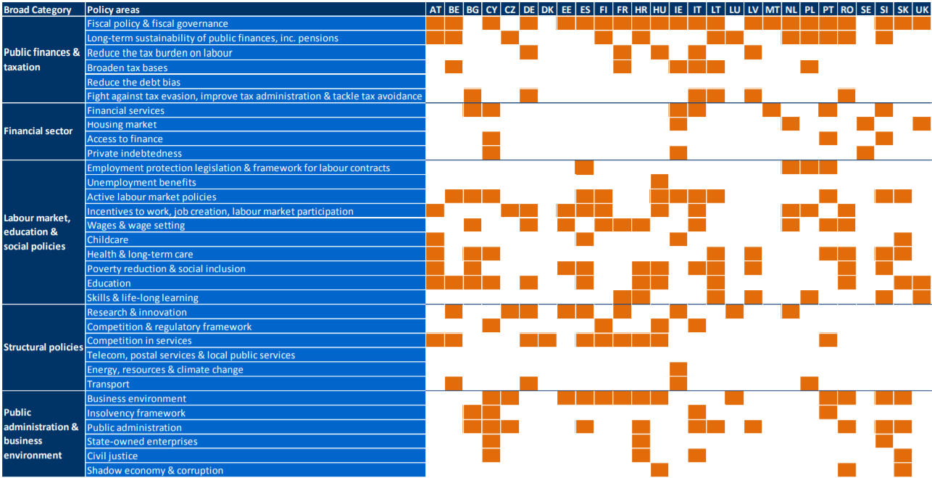

The European Semester is in 2017 applicable to 27 Member States. Greece is implementing an economic adjustment programme and is therefore not subject to surveillance under the European Semester.
EPF Access to Healthcare Survey Report, December 2016 http://www.eu-patient.eu/globalassets/policy/access/final-access-survey-report_16-dec.pdf
EPF Campaign on Access to Healthcare for All http://www.eu-patient.eu/campaign/access-to-healthcare/
Communication from the Commission: 2017 European Semester: Country-specific recommendations https://ec.europa.eu/info/sites/info/files/2017-european-semester-country-specific-recommendations-commission-recommendations-communication.pdf

