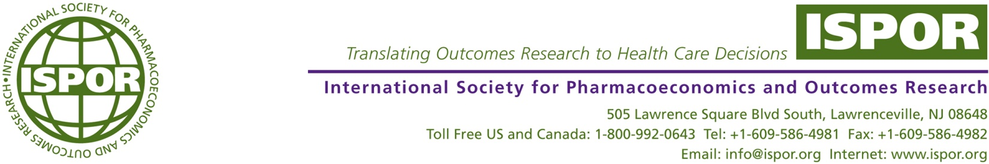

September 2, 2015

Dear Patient Representatives,

The International Society for Pharmacoeconomics and Outcomes Research (ISPOR) would like your assistance in completing a case report on patients and patient representatives’ experiences, positive and negative, with the HTA processes. The results of this exercise are intended to benefit patients and HTA organizations in creating a better understanding of what works and does not work for patients when they are engaged and will be presented by Nicola Bedlington at the ISPOR European Congress in Milan November 10th.

The template (provided as Word or PowerPoint document for ease of use) should take no more than 10 minutes to complete and the findings will be held in confidence. We may identify themes that emerge for public discussion but will not specifically identify those who provided information. One template can be completed for each HTA interaction. Completed templates should be sent to Don Husereau at [don.husereau@gmail.com](mailto:don.husereau@gmail.com), who is compiling the survey results by Friday, October 9th.

This information is being collected for the ISPOR Patient Representatives Roundtable, which provides patient representatives the opportunity to learn and discuss with other stakeholders how patients can participate in the assessment of a new health technology (drug, medical device, diagnostics, biopharmaceutical, vaccines) and increase their involvement in health policy decision making.

ISPOR is a non-profit, international, educational and scientific organization that fosters excellence in health economic and outcomes research and the use of outcomes research information in health care decisions. For more information on the Society, please go to [www.ispor.org](http://www.ispor.org).

If you have any further questions or would like information on how you can become involved with ISPOR patient-led activities, please contact Don Husereau at [don.husereau@gmail.com](mailto:don.husereau@gmail.com) or Theresa Tesoro at [ttesoro@ispor.org](mailto:ttesoro@ispor.org). We look forward to your participation in this important project

Sincerely,



Nadia G. Naaman

Senior Director, Scientific & Health Policy Initiatives

nnaaman@ispor.org