Work Package 7

Deliverable 7.2

Framework for patient involvement in regulatory processes

Table of Contents

1. Overarching principles for patient involvement throughout the medicines research and development process 3
2. Scope of the regulatory framework 3
3. Rationale for the framework 4
4. Objectives 6
5. Recommended working methods (adapted from the EMA framework) 7
6. Implementation and monitoring 8
7. Abbreviations 11

Overarching principles for patient involvement throughout the medicines research and development process

  - The great majority of experts involved in the development and evaluation of medicines are scientists. There is an increasing need to understand what it is like to live with a specific condition, how care is administered and the day-to-day use of medicines and to draw on this experience and specific knowledge of patients in order to promote discovery of new effective drugs and improve their development and evaluation.
  - Structured interaction between patients, their representatives and other stakeholders is necessary and allows the exchange of information and constructive dialogue at national and European level where the views from users of medicines can and should be considered.
  - We recommend close cooperation and partnership between the various stakeholders including healthcare professionals’ organisations, patients’ and consumers’ organisations, academia, scientific and academic societies, regulatory authorities and health technology assessment (HTA) bodies and the pharmaceutical industry. Experience to date demonstrates that close cooperation with patients has resulted in increased transparency, trust and mutual respect between them and other stakeholders. It is acknowledged that their contribution to the discovery, development and evaluation of medicines enriches the quality of the evidence and opinion available.
  - Existing codes of practice for patient involvement with various stakeholders do not cover the research and development (R&D) period. Where frameworks already exist, they have been written for use by a specific body (for example the European Medicines Agency, EMA). The EUPATI framework aims to support the development of patient involvement across the entire process of medicines development and evaluation.
The framework is presented as four separate guidance documents covering patient involvement in:
- pharmaceutical industry-led medicines R&D
- ethics committees
- regulatory authorities
- health technology assessment (HTA).
Each guidance suggests areas where at present there are opportunities for patient involvement.
  - This guidance covers the regulatory field and draws on the mature “Framework for interaction between the European Medicines Agency and patients and consumers and their organisations”.

Scope of the regulatory framework

This framework covers the interaction between patients and medicines regulatory authorities in relation to medicines for human use. “Patients” can be individual patients or their carers, or representatives from patient organisations with relevant expertise. Regulatory authorities include both National Competent Authorities (national regulatory authorities) and the European Medicines Agency (EMA). Patients and consumers’ organisations are not-for-profit organisations that have an interest in patient care, and where patients and consumers represent a majority of members in governing bodies.

  - The framework focuses on involvement, and excludes the scientific collection of patient perspectives (i.e. it excludes quantitative and qualitative systematic research on the psychosocial impact of diseases and treatments).

Rationale for the framework
The extent of patient involvement in regulatory issues varies considerably between countries and regions in Europe.
The EMA has interacted with its stakeholders since its creation in 1995. These stakeholder relations have evolved over time and the type and degree of interaction varies depending upon the stakeholder group concerned and the type of EMA activity. The EMA Management Board and certain scientific committees include patients and consumers as members.
The benefit of stakeholder involvement experienced by the EMA has resulted in several national regulatory bodies implementing a framework at national level too. Most national regulators draw on the EMA’s experiences.
  - The involvement of patients with the EMA is determined by European legislation. EMA, its Management Board and its various scientific committees are responsible for developing the relationship between the EMA and its stakeholders.
There is existing legislation which defines:
- Direct interaction between the EMA and patients’ and consumers’ organisations, through the Patients’ and Consumers’ Working Party (PCWP),
- The framework for providing clear and useful information to these organisations.
- Specific forms of interaction, e.g. patients’ membership in the EMA Management Board, the Committee for Orphan Medicinal Products (COMP), the Paediatric Committee (PDCO), the Committee for Advanced Therapies (CAT), Scientific Advice/Protocol Assistance procedures with the Scientific Advice Working Party (SAWP) and the Pharmacovigilance and Risk Assessment Committee (PRAC).
- In addition, the EMA has put in place methods to collect patients’ input through direct consultation.

  - The experience acquired to date demonstrates that the participation of patients in EMA activities has resulted in increased transparency and trust in regulatory processes and mutual respect between regulators and the community of patients and consumers. The positive experience confirms the importance for EMA to continue supporting and facilitating patient contribution to its work.

  - Similar legislative provisions may be lacking at the national level. In the absence of legal provisions, National Competent Authorities may base their framework on EMA experience or develop a framework on their own. Key elements to consider for such a framework include:
- Define the role of patients in the interaction
- Include proposals on involving patients in specific institutional processes
- Develop a training programme
- Consider a concept for expert compensation, applying to all stakeholders

  - Any framework needs to be reviewed on a regular basis.

Objectives

Streamlining the interactions with patients, and focusing on areas where mutual benefit can be anticipated, are two underlining principles to consider when implementing a framework.

The framework should aim at further building transparency and trust with patients’ and consumers’ communities through their active engagement (participation-consultation- information). In order to achieve this goal, the framework should aim at meeting specific objectives such as:
      - Supporting the regulator to access real-life experiences of diseases and their management and to obtain information on the current use of medicines. This will contribute to understanding the value, as perceived by patients, of the scientific evidence provided during the evaluation process for the purposes of benefit/risk decision-making.
      - Ensure that patients, consumers and their representative organisations are listened to and consulted and where appropriate involved in the development of policies and plans;
      - Enhance patients’ and consumers’ organisations understanding of the mandate and role of the regulator within the context of the development, evaluation, monitoring and provision of information on medicines;
      - Optimise communication tools (on content and delivery) to facilitate and encourage the cascade of information to the constituencies of patients’ and consumers’ organisations (i.e. to reach out to individual patients and consumers) with the aim of supporting their role in the safe and rational use of medicines;
      - Facilitate participation of patients and consumers in benefit/risk evaluation and related activities, to capture patients values and preferences and obtain information on the current use of medicines and their therapeutic environment, all along the lifecycle of medicines development, from early development throughout evaluation and post-marketing surveillance.

Achieving these objectives will necessitate close collaboration between the regulatory authority, national ministries of health, and other relevant stakeholders, as well as an active participation and good interaction with patients, healthcare professionals and their representative organisations.

Recommended working methods (adapted from the EMA framework)

  - Based on experience of the EMA at European level, patients and consumers can participate in the regulatory authority’s activities:
    - as members (and alternates) of some of the regulatory authority’s (scientific) committees or working groups and, in case of the EMA, of the EMA’s Management Board (formally appointed by the EU Institutions).
    - as individual experts.
    - as representatives of a specific organisation, to be consulted and participate in discussions to express the views of the organisation on a specific issue.
    - occasionally as observers in certain aspects of the EMA’s or regulatory authority’s work.
Regulatory authorities should establish criteria for eligibility.

When patients and consumers participate in regulators’ activities as individuals and not as representatives of their organisation, they should declare any interest and abide by the regulator’s code of conduct. In addition, the organisations involved should be fully transparent with regard to their activities and funding sources.
  - In order to achieve the objectives identified under section 4, the following five elements should be considered as critical:
    - A network of patients’ and consumers’ organisations (potentially in collaboration with other regulators)
The network of patients’ and consumers’ organisations allows the regulator to build up consistent and targeted interactions with a broad group of organisations with a diverse range of expertise and interests. Selection criteria should apply. Such criteria should ensure that the regulator establishes contact with the most suitable organisations representing patients and consumers in a transparent manner. Within a network, the criteria should be harmonised.
    - A forum of exchange with patients’ and consumers’ organisations established within the regulatory authority
This is a platform for dialogue and exchange with patients’ and consumers’ organisations on relevant issues concerning medicines for human use; through it the regulator will inform and will obtain feedback and contribution from patients and consumers on various regulator’s initiatives. It includes a balanced representation of the different types of patients and consumers as well as organisations representing special populations not well represented in medicines development such as older people and women. It should provide a forum to further identify gaps and priorities in the overall interaction.
    - A pool of individual patients acting as experts in their disease and its treatment to facilitate patients’ involvement in medicines evaluation and information
The creation of the pool of experts will enable the regulator to quickly and efficiently identify patients who can be involved in product-related activities, review of product information and communication material.

    - Interaction particularly in the field of communication

This will provide a valuable contribution to support the existing structures for information dissemination to the public. Furthermore, collaboration in this area will promote the provision of validated and up-to-date information to patients and consumers on the benefits and risks of medicines and contribute to the preparation and dissemination of clear messages on the safe and rational use of medicines intended to reach the public. Any information material to patients should be reviewed by a patients’ representative to improve readability and appropriateness of language and content.

    - A programme of actions for capacity-building, focusing on training and raising awareness about the regulatory system, as well as financial support
For their contribution to be meaningful, patients must have an understanding of the regulator’s mandate as well as the patient’s expected role in the evaluation process. A training programme should be available. Some patients’ organisations or other collaborative projects have developed their own training material in order to empower patients to play a recognised advocacy role.

Financial support should be provided to patients contributing to the regulator’s activities. This would represent an acknowledgement of the work they do while promoting their independence.

Implementation and monitoring

A patient involvement framework can be introduced step-by-step and/or following a pilot phase where appropriate. After full implementation, it is recommended to present a public annual report on interactions, including an analysis of performance indicators, feedback received from patients and consumers and their representative organisations through targeted surveys, an overview of the work undertaken by the group, and an overview of the activities common to patients, consumers and healthcare professionals.

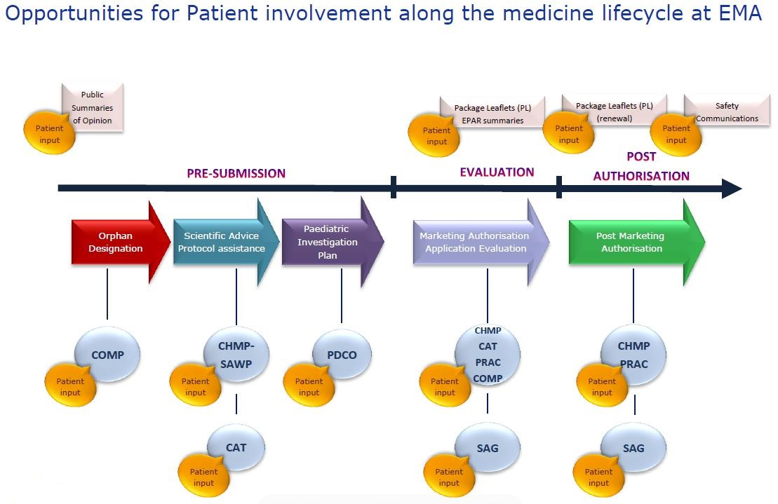

  - This version of the framework has been approved by XXXXX.

Abbreviations

Regulation (EC) No 726/2004

